Carageenan Results Graphs

## Option 1

* Bars are arranged in decreasing order of yield in areas not applied with carageenan.
* Two separate plots (by season).

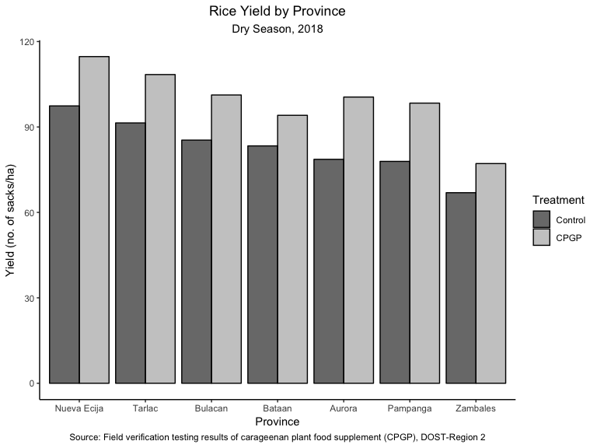

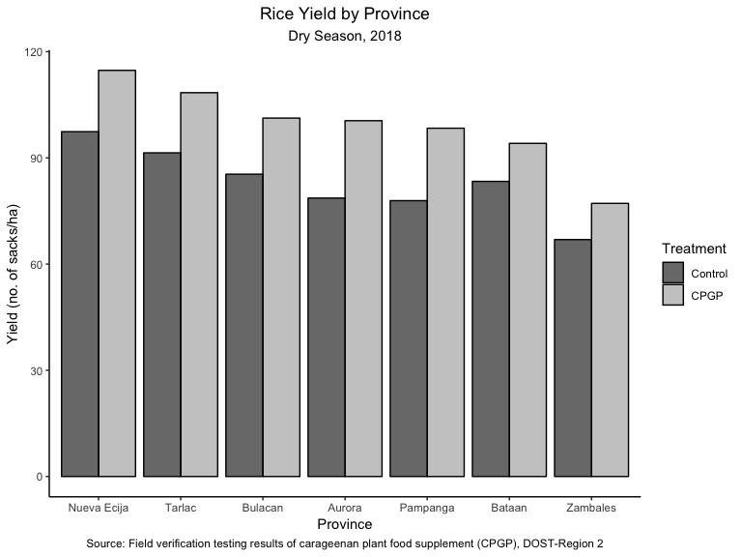

## Option 2

* Bars are arranged in decreasing order of yield in areas applied with carageenan.
* Two separate plots (by season).

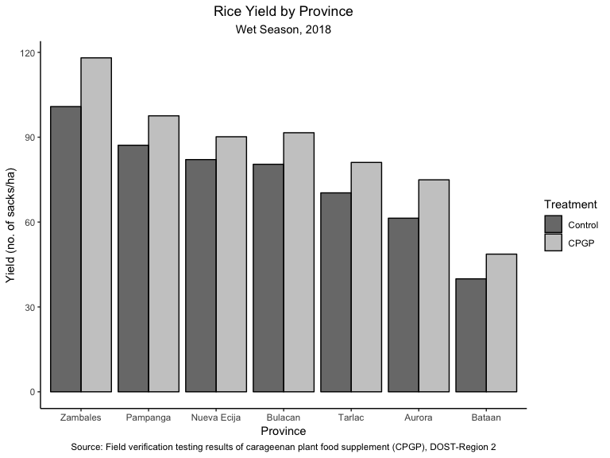

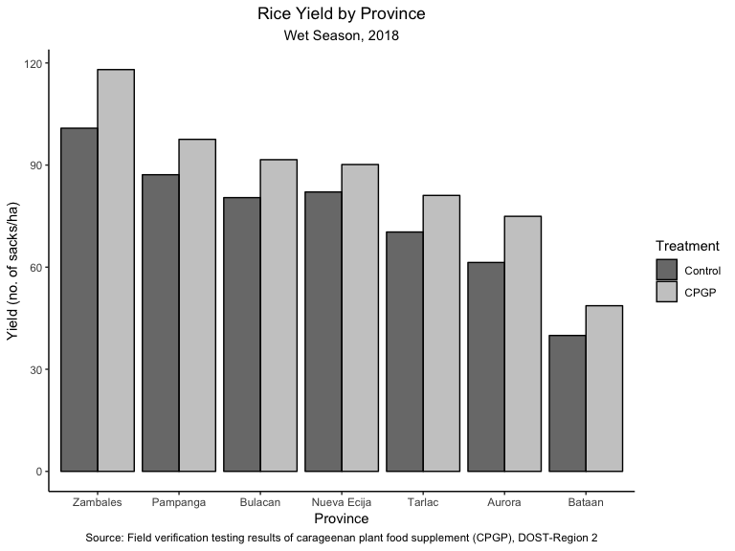

## Option 3

* Bars are arranged in decreasing order of percentage difference of yield in areas applied with carageenan over the yield in areas not applied with carageenan.
* One plot with two subplots (by season).

